Appendix 3.8

Interfaces for grid connection of Thor offshore wind farm
Table of contents
1. 220 kV grid connection 2
2. Ownership boundaries 2
2.1 Energinet's property 2
2.2 Concession winner's property 2
2.2.2. Maximum number of connected wind turbines: 3
2.3 Settlement metering 3
3. Other conditions 4
3.1 Location and layout of coastal substations 4
3.2 Zero-point resistors 6
3.3 Earthing system 6
3.4 Grid connection agreement 7
Appendix 8

1. 220 kV grid connection
Thor offshore wind farm is connected to Energinet's transmission system via a 220 kV point of connection (POC) in a new coastal 220 kV high-voltage substation. The substation is called Volder Mark, abbreviated VMA, and is established and owned by Energinet. The VMA substation has three 220 kV GIS coupler bays, to which the concession winner connects two or three 220 kV single core cable systems. The GIS coupler bays and the overall switchgear are established as indoor GIS equipment using 245 kV equipment.

The HVAC connection interface between Energinet and the concession winner is located where the b
As the concession winner shall connect the 220 kV cables to Energinet's GIS coupler bays, the cables must be terminated with Connex connectors which are connected to Connex sockets in Energinet's GIS coupler bays. This connection will be established by the concession winner, as well as the switchboards with equipment and routing of signal cables.

The concession winner establishes, owns and operates the high-voltage equipment up to and including the termination of the concession winner's HV cables with associated communication and protective equipment to be connected at Energinet's 220 kV Volder Mark substation (VMA).

An overview of interfaces and the concession winner's deliverables in connection with the Landing facility are described below. The appendices at the end of the document contain drawings and maps showing the location and interface in the High-Voltage substation at the POC. The appendices may be obtained as separate PDF documents.

A detailed design description of the point of connection and the interface between the concession winner and Energinet can be found in Appendix 2.1 of the grid connection agreement.

2. Ownership boundaries

2.1 Energinet's property
Energinet owns, operates and maintains the following:
- All facilities from Idomlund substation (IDU) up to and including Energinet's coastal Volder Mark substation (VMA), excluding the concession winner's 220 kV cables with the terminations connected to Energinet's 220 kV GIS coupler bays. Similarly excluded are any switchboards with associated signalling equipment/signal exchange and relay protection relating to protection of the concession winner’s cables.
- The area equal to the northern part of land cadaster “7f” at Volder Mark.
- 220 kV surge arresters.

2.2 Concession winner's property
The concession winner establishes, owns, operates and maintains the following:
- All facilities from the offshore wind farm up to and including termination of the two or three 220 kV cables connected to Energinet's 220 kV GIS coupler bays at Volder Mark substation (VMA).
- switchboards and signal cables for the exchange of signals and protection of the concession winner's cables at the Energinet-owned Volder Mark substation (VMA).
- The area equal to land cadaster “7h” at Volder Mark.
- Settlement metering is established in the POC by the local electricity supply company and is paid by the concession winner.

See also Appendix 2.1 of the grid connection agreement.

2.2.2. Maximum number of connected wind turbines:
See Appendix 3.2 of the concession agreement (permission to establish), item 1.1.

2.3 Settlement metering
Settlement metering must take place in the point of connection (POC) in the 220 kV GIS coupler bays, where the concession winner's cables are connected at Volder Mark substation (VMA). The local supply company Nordvestjysk Elforsyning (NOE) must record metered data, and the concession winner must cover all expenses related to the establishment of settlement metering.

Metered data will comprise data from the current transformers built into Energinet's two 220 kV GIS coupler bays, to which the concession winner's cables are connected, and from voltage metering on Energinet's 220 kV busbar at Volder Mark substation (VMA).

For more information, please see Regulation "D2 – Technical requirements for settlement metering" (Tekniske krav til elmåling), which can be downloaded from Energinet's website via this link (Danish only): http://Energinet/DA/El/Forskrifter/Tekniske-forskrifter/Sider/Forskrifter-for-systemdrift.aspx

The specification of equipment for settlement metering installed at the concession winner's facilities (cables, voltage transformers, cables, etc.) must be approved by Energinet.

3. Other conditions

3.1 Location and layout of coastal substations
The Volder Mark substation (VMA), which is the point of connection (POC), will be located about 5 km from the coast and about 3 km south of the town Ramme. Up to about 200-400 m west of the point of connection, the concession winner is expected to establish its own coastal substation called Volder Søndervang substation (VSG). The two substations will be separate from each other, and each will be on separate plots of land with separate fences.

The concession winner must independently acquire the land required to establish the Volder Søndervang substation (VSG) and acquire the rights for cabling all the way to the point of connection (POC).

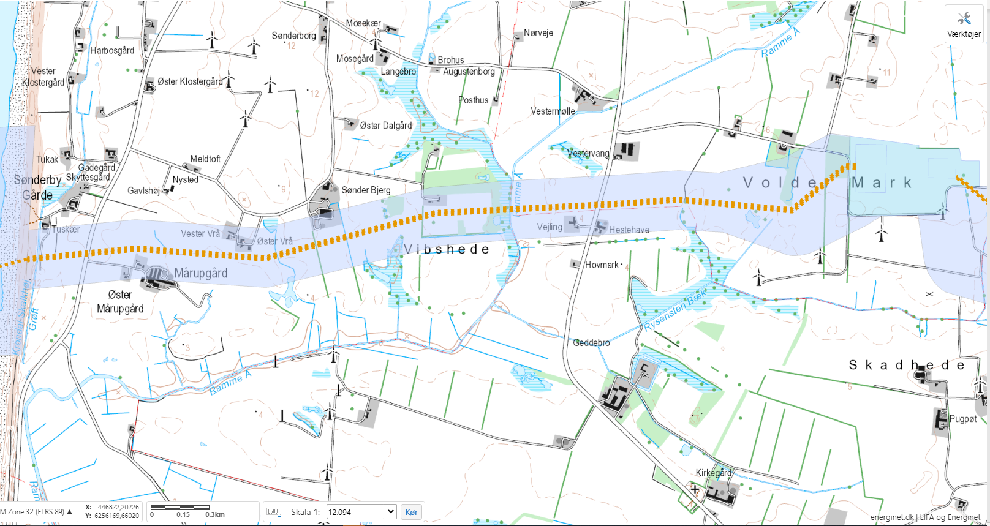
Figure 1 Shows the planning strip from the coast up to Volder Mark, where the two coastal substations Volder Søndervang (VSG, to the west) and Volder Mark (VMA, to the east) are located. The distance between the coast and the area with the two coastal substations is about 5 km.

A local plan (local zoning plan) has been created for the area around Volder Mark, and as of May 2021, work is proceeding based on a sketch, see below.
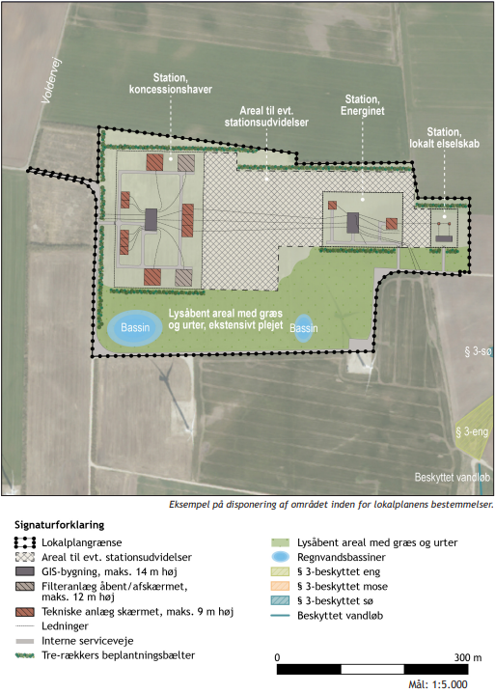

Figure 2 Concept for integrating the two coastal substations at Volder Mark. Volder Søndervang (VSG, concession winner, farthest to the west) and Volder Mark (VMA, Energinet, farthest to the east).
The cart below shows land cadasters for the area included in the local plan.

Energinet only buys the area equal to the northern part of land cadastre “7f” and for that area only, fulfil the obligations stated in the local plan, planting etc.

The concession winner is responsible for buying the area equal to the land cadastre “7h” and for that area, fulfil the obligations stated in the local plan, planting etc.

Figure 3 Shows the area around the two coastal substations at Volder Mark included in the local plan (local zoning plan). The concession winner is responsible for buying the area marked with yellow and for that area, fulfill the obligations stated in the local plan.

3.2 Zero-point resistors
Will be clarified later when configuration of substation VSG is determined.

3.3 Earthing system
Energinet's recommendations for an earthing system are described in internal Energinet document EGS-125, Installation description for earthing system.

3.4 Grid connection agreement
The concession winner must enter into a grid Connection Agreement incl. its appendices with Energinet.

The draft grid connection agreement and its appendices are included in the overall tender documents. Some appendices are not included in the draft.

The concession winner must provide Energinet with a contact person who will handle coordination issues. The parties will each bear their own costs incurred during the collaboration.

The concession winner must be actively involved in the coordination of interfaces in the point of connection (POC).

Appendix

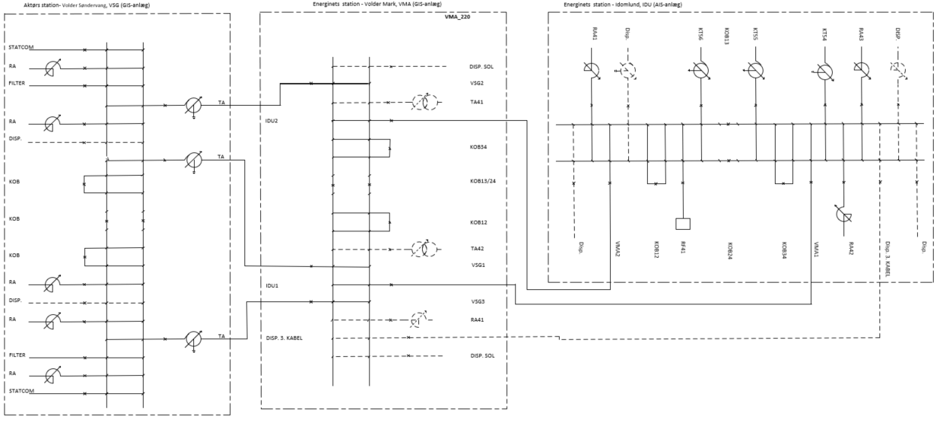
220 kV Idomlund substation (IDU)
Energinet
220 kV Volder Mark substation (VMA)
(Energinet)
220 kV Volder Søndervang substation (VSG)
(Tender winner)
Figure 4 The draft single-line diagram (SLD) from Idomlund, via Energinet's coastal Volder Mark substation (VMA), to the concession winner's coastal Volder Søndervang substation (VSG).
WMP3 = connection of Thor, cable 3 (if applicable)
WMP1 = connection of Thor, cable 1
VSG2 = connection of Thor, cable 2
VSG3 = connection of Thor, cable 3
VSG1 = connection of Thor, cable 1
POC
and
Settlement point
VSG2 = connection of Thor, cable 2
VSG2 = connection of Thor, cable 2
Ownership boundary
Figure 5 Energinet-owned 220 kV Volder Mark substation (VMA) – SLD showing POC, ownership boundaries and settlement point. There is one POC, which is on the 220 kV busbar, and which is also the settlement point. The concession winner establishes, operates and owns the terminations of the 220 kV cables coming from Volder Søndervang and is responsible for connecting the cables in the cable termination modules (in VSG1, VSG2, and VSG3).
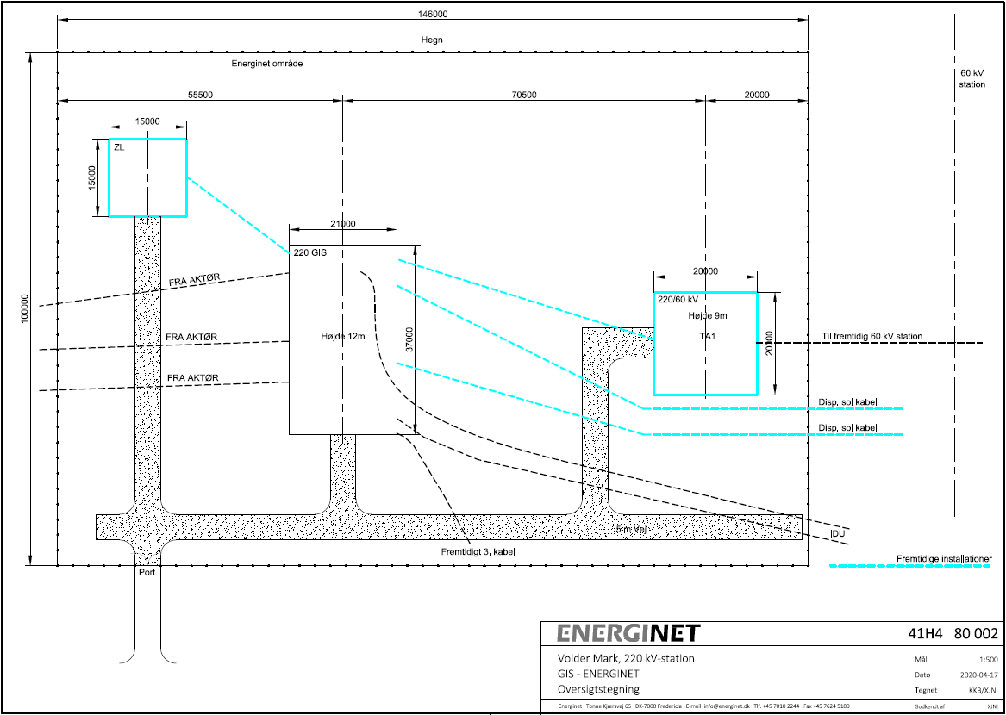
Figure 6 Energinet-owned 220 kV Volder Mark substation (VMA) – draft layout drawing. Marked in light blue: possible future expansions.

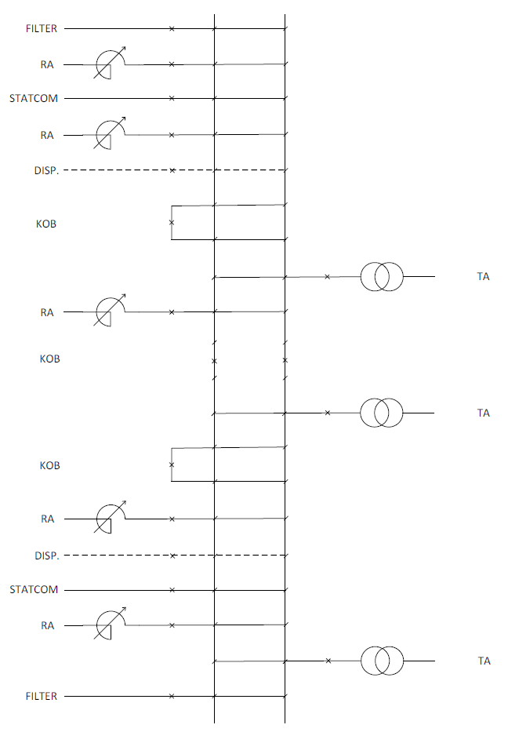
Figure 7 Concession winner-owned 220 kV Volder Søndervang substation (VSG) – draft concept for overall SLD.
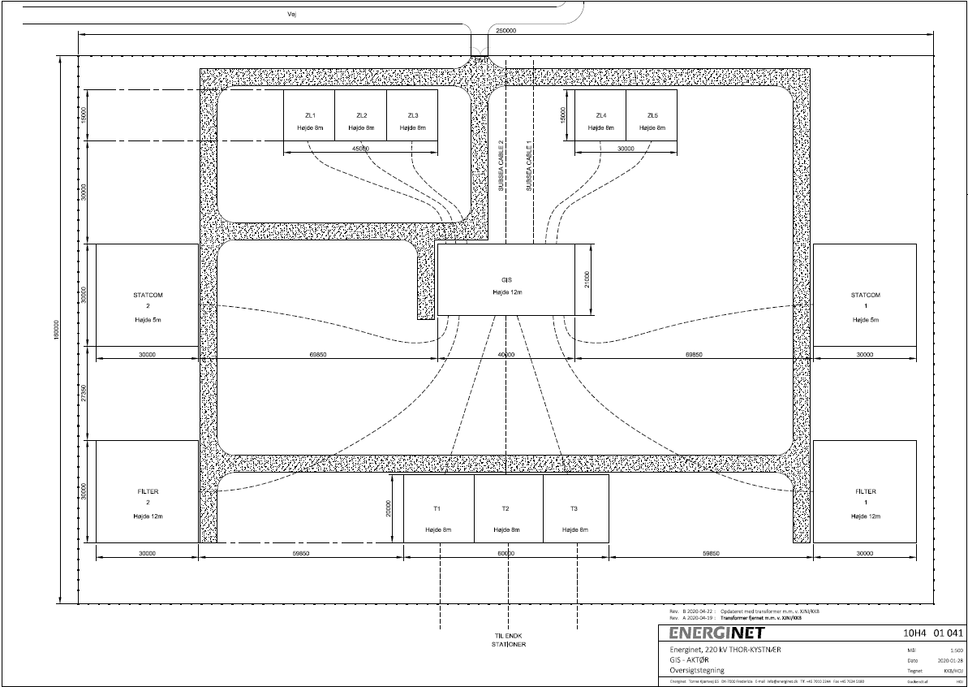
Figure 8 Concession winner-owned 220 kV Volder Søndervang substation (VSG) – draft concept for layout drawing.
Figure 9 Shows the planning strip for cables from the coast to the area containing the coastal substations at Volder Mark.
Figure 10 Concept for integrating the two coastal substations at Volder Mark. Volder Søndervang (VSG, concession winner, farthest to the west) and Volder Mark (VMA, Energinet, farthest to the east).

